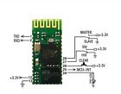**BC04-B Bluetooth to UART Module Industrial Master-Slave Wireless Bluetooth AK**

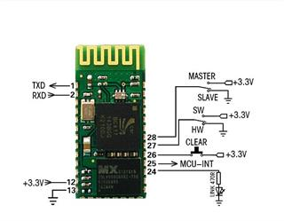

## **Description**

1.Adopt the mainstream CSR bluetooth chip, the bluetooth V2.0 protocol standard

2. Serial port module working voltage 3.3 V, Transmission distance is about 15 meters

3. Default baud rates is 9600,it can be set by user.

4. Working status indication, connection and disconnected status signal output, is advantageous for the MCU to track the state of module

5. Core module size: 26.7 x 13 x 2.2 mm

6. Working current:matching: 2~30mA .matched but not communication: 5~6mA communicating: 10mA

7. Sleep current: don't sleep, but support low power mode

8. Used for GPS navigation systems, water and electricity gas meter reading system, industrial control system.

9. Can add bluetooth adapter with bluetooth laptops, computers, PDA and other equipment for seamless connectio

Packing List:1Pcs

More Information:

<http://www.electrodragon.com/w/BC04>

AT Command Set:

<http://www.electrodragon.com/w/AT_Commands>